Determining Chemical Formulas

Law of Constant Composition: compounds contain elements in fixed proportions…. Always the SAME!

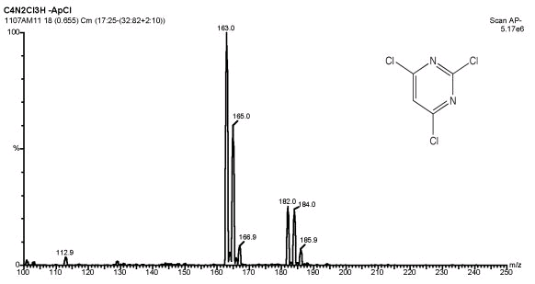
Equipment for determining the formula (proportions):
- Mass Spectrometer (CSI): can determine the molar mass of many compounds by vapourizing a small sample, ionizing it (giving it a charge) and deflecting the charged gas in a magnetic field. The amount of deflection gives the mass.
- Combustion Analyzer: Determines amount of C, H, O and N by burning the substance in pure oxygen and analyzing the products.

Empirical Formula
- Gives the lowest ratio of atoms in a compound, but may not tell the exact number of each type of atom
VS.

Molecular Formula
- Indicates the actual numbers of atoms in one molecule of a compound

 | Molecular | Empirical
Hydrogen peroxide
Sugar

Percentage composition: percentage, by MASS, of each element in a compound

Examples (p111):

